**Experiment 5 – Report**

**Team 2**

**(Bhuvanesh P, Krishna Sah Teli, Sai Kiran)**

**Aim**

The Aim of the experience is to find the Brix value of the given fruit sample using the wavelength data collected, utilizing the regression model build up using the previous data collected.

**Interactance and Brix value of Fruits**

Interactance spectroscopy is a non-destructive analytical technique used to investigate the properties of a material or a sample by measuring the intensity of light reflected from or transmitted through the sample. In interactance spectroscopy, a beam of light is directed onto the surface of the sample, and the reflected or transmitted light is analysed using a spectrometer. The resulting spectra provide information about the electronic, vibrational, or other physical properties of the material, including its composition, structure, and optical properties.

Interactance spectroscopy can be used to analyse a wide range of materials, including polymers, semiconductors, biological tissues, and thin films. Overall, interactance spectroscopy is a powerful tool for materials science, chemistry, and biochemistry, and is widely used in research and industry to characterize and optimize materials for various applications.

Interactance spectroscopy can be used to study the Brix value of fruits by measuring the intensity of light reflected or transmitted through the fruit. Brix value is a measure of the sugar content of a fruit or vegetable, which is important for determining the fruit's quality and ripeness.

To measure the Brix value of a fruit using interactance spectroscopy, a beam of light is directed onto the surface of the fruit, and the reflected or transmitted light is analysed using a spectrometer. The resulting spectrum can be used to determine the sugar content of the fruit based on the absorption of light at specific wavelengths.

The Brix value can also be determined by comparing the reflectance or transmittance spectrum of the fruit to a reference spectrum obtained from a fruit with a known Brix value. The difference between the two spectra can be used to calculate the Brix value of the fruit being tested

**Procedure**

* First Build up a model using the regression data provided. There are about 400 files having 18 wavelength value corresponding to different varieties of apples. To build a model, we need to take average of vales in each file mapped with the corresponding brix value of the fruit. Few files are redundant with no corresponding brix vales which can be removed.
* Wavelength values needs to be normalized with a reference value which was provided in a different file. The reference values also need to be averaged before using.
* The we should calculate absorbance by taking negative logarithm of it
$$Absorbance= -log⁡(\frac{I_{i}}{I_{0}})$$

* Ultimately the data the need to be feed into the model is the absorbance corresponding to the 18 wavelengths and the corresponding brix values of different apples.
* After building the regression model, the corresponding RMSE and R-square should be calculated for reporting.
* Then for calculating the measuring the wavelength, a sensor board equipped with 3 LEDs (these serve as the source for the UV, visible and IR wavelengths) which is connected with an audrino board. The code for operation needs to be uploaded to the board.
* Then we need to write another code to get the data collected by the sensors using the pyserial module.
* The data collected will be in the form of bits which needs to be converted back. The collected data should be saved in the form of a csv file. We need about 20-25 readings of wavelength in the csv file.
* The data again needs to be averaged out. The after calculating the absorbance corresponding to 18 wavelengths, the data is fed into the model which gives the Brix value.
* The data needs to be collected for 2 different apples at 3 spots each

**Observation and results**

All the csv files corresponding to the six different sample points and the code used for model building and data collecting was already sent. The Regression model summary is given below. It can be very well observed that the R2 is very low hence we can assume that the model may not be well fit in this scenario.

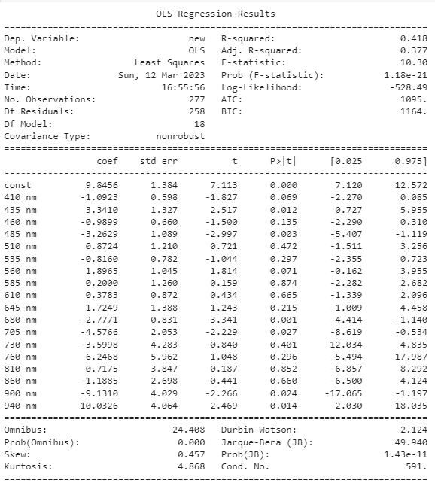

**The Brix values of the fruits calculated**

|  |  |
| --- | --- |
| Apple Sample | Brix Value |
| Apple 1 – Sample 1 | 12.87361896 |
| Apple 1 – Sample 2 | 14.42900778 |
| Apple 1 – Sample 3 | 12.57259733 |
| Apple 2 – Sample 1 | 15.26317029 |
| Apple 2 – Sample 2 | 14.50660869 |
| Apple 2 – Sample 3 | 13.13188387 |

**Inference**

As suggested before, the regression model was pretty bad with very low fit to the data. The Brix values of the fruits was observed to be very high, some even going past 15 which is a little higher than usual. This maybe as a result of the in proper model in use. With more relevant data, perhaps the model accuracy can be improved along with the Brix values estimated.